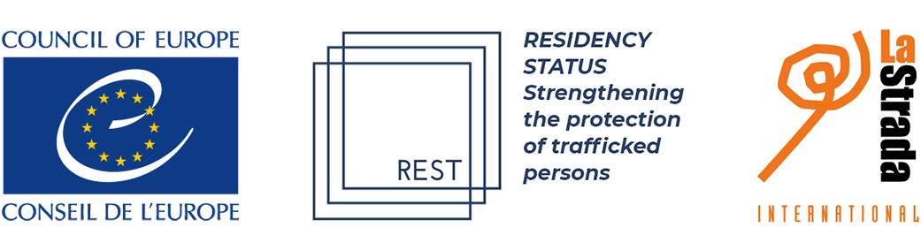

ACCESS TO RESIDENCE FOR TRAFFICKED PERSONS

4 June 2021, 15.00 – 16.00 CET, via zoom

This side event, organised on the margins of the 28th meeting of the Committee of the Parties to the Council of Europe Convention on Action against Trafficking in Human Beings, will focus on the importance of improved access to residence for victims of trafficking, on the basis of a recently launched research report Residence Permits, International Protection and Victims of Human Trafficking.

This REST study – partly funded by the Council of Europe – reviewed the international and European legal framework on access to residence permits and international protection for trafficked persons and its implementation at the national level in the following six countries: Austria, France, Republic of Moldova, the Netherlands, Serbia and Spain. The study analysed 42 cases, reviewing the victims’ referral to different channels of protection. The research found that a very low number of registered trafficking victims have access to international protection procedures, and that residence permits for trafficked persons are often made conditional on their participation or willingness to participate in the investigation or criminal proceedings of the case.

These findings confirm GRETA’s monitoring conclusions on the issue. Out of the 42 countries evaluated by GRETA, 22 had legislation envisaging the issuing of residence permits to victims of trafficking both owing to their personal situation and for the purpose of their co-operation in the investigation or criminal proceedings. A further 14 countries granted residence permits to victims of trafficking exclusively for the purpose of their co-operation with law enforcement, and two had legislation providing for the issuing of a residence permit to victims of trafficking on humanitarian grounds.

The REST study provides best practice examples and recommendations on how States can ensure that trafficked persons can access residence and are provided with the most appropriate protection to secure rights and access to a durable solution.

ModeratIon: Suzanne Hoff, La Strada International

- Introduction by Ms Petya Nestorova, Executive Secretary of the Council of Europe Convention on Action against Trafficking in Human Beings
- Findings of the research by Ms Evelyn Probst, Head of LEFÖ IBF, Austria and board member of La Strada International, and Ms Mona Chamass, Director of CCEM, France
- Reflection on research findings and situation in the Netherlands by Professor Conny Rijken, GRETA member

Please register here and see link to connect to the event via zoom here

